|  |  |  |
| --- | --- | --- |
| **Capstone Form – Paper Review ARC Writing Lab Report** | | |
| Work with the ARC Writing Lab (schedule in advance) to review your paper and complete this form. Provide the ARC a blank copy of this form and rubric. *Submit a copy of your capstone project as reviewed and a signed copy of your report. ARC Writing Lab scheduling information can be found online at:* [*https://cairn.edu/arc/*](https://cairn.edu/arc/) | | |
| Name: | **Turn in a typed, fully completed form. Partially completed forms, handwritten forms, or late submissions will not be accepted.** | |
| Indicate which paper review was completed:  Paper Review 1 – includes a title, introduction, background, 5+ pages of meticulously proofread content, and an alphabetized bibliography with a minimum of 10 sources  X Paper Review 2 - includes a title, 25 to 30 meticulously proofread pages, all footnoted citations, and an alphabetized bibliography of 20+ sources with at least 50% from professional articles or books | | |
| Paper meets requirements outlined above: | | *Yes or No* |
| Paper meets graduate level expectations outlined in grading rubric:  (*Paper Review 1 = All Drafts Rubric; Paper Review 2 = Final Paper Rubric*) | | *Yes or No* |
| Paper Strengths:  1. Good Structure  2. Appropriate APA Structure  3. Good in-text citations | | |
| Paper Weaknesses:  1. Spelling Errors  2. Consistency of capitalizing proper nouns  3. Hanging Indentation of References  4. Finish Writing Conclusion | | |
| Corrective Action Plan:   1. Finish Writing the Conclusion 2. Edit 2nd half of the paper for Spelling & Grammar issues 3. Finish References section with In-text citations by sorting alphabetically & Hanging Indentation | | |

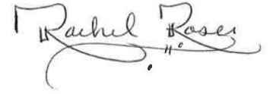4/22/2021

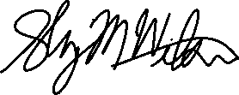

Student Signature & Date ARC Writing Lab Signature & Date



*I affirm that I have completed this assignment in accordance with the Cairn University’s Policy on Academic Integrity.*